Name:__________________________________ Date:___________ Period:_____ Table:_____

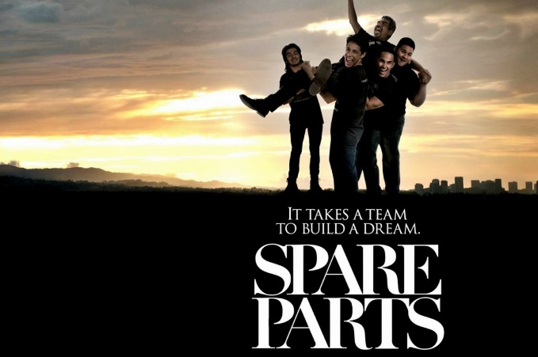
Study Guide Part 1
- What item is missing from Oscar Vasquez’s file when he goes to enlist with the Army?

- Why does Mr. Cameron say he wants to teach?

- How many students does the principal say go on to college from their high school?
- 1/2
- 1/3
- 1/4
- 3/4

- What does Lorenzo charge Mr. Cameron to fix his car?

- Why do the textbooks stay locked up?

- How many students show up for the engineering club on the first day?

- Christian offers to program __________________________ for the bully in the library.

- How many parts are there in the obstacle course for the robotics competition?
- 5
- 6
- 7
- 8

- What does the team build the sample robot out of?

- What does MIT stand for?

- What does Mr. Cameron say is the reason he can’t donate to the team?

- The bank donates $________ to Oscar. What other businesses finally donate to the club?

- Why did Oscar say McDonald’s is a special place to him?

- How much money did they raise to build their robot?

- Mr. Cameron writes a check for $____________ at the hardware store. When the boys say they thought he wasn’t allowed to donate he tells the boys its robotics competition and not a _____________________ competition

- What do they name the robot?
- Slimy
- Smelly
- Slippery
- Stinky

- What prevents the robot from working properly when they do the test run at the pool?

- Why does Lorenzo’s dad make him cover for his younger brother?

